UNDRUND UN**College Management System**

**ADITYA AGARWAL (1516210007)**

**AVTAR CHANDRA (1516210019)**

**ANUBHAV MISHRA (1516210018)**

**Submitted to the Department of CSE**

**In partial fulfillment of the requirements**

**For the degree of**

**Bachelor of Technology**

**In**

**Computer Science and Engineering**



**Shambhunath Institute of Engineering & Technology**

**(Affilated to: Dr. APJ Abdul Kalam Technical**

**University, Lucknow,Uttarpradesh,India)**

**ACKNOWLEDGEMENT**

It gives us a great sense of pleasure to present the report of the B.Tech Project undertaken during B.Tech. Final Year.

We owe special debt of gratitude to Professor Amit Srivastava,Department of computer science and engineering of Shambhunath Institute of Engineering, & Technology Prayagraj for his constant support and guidance throughout the course of our work.

His sincerity, thoroughness and perseverance have been a constant source of Inspiration for us. It is only his cognizant efforts that our endeavors have seen light of the day.

We also do not like to miss the opportunity to acknowledge the contribution of all faculty

members of the department for their kind assistance and cooperation during the development of

our project. Last but not the least, we acknowledge our friends for their contribution in the completion of the project.

Signature: Signature: Signature:

Name : Name : Name :

Roll No.: Roll No.: Roll No.:

Date : Date : Date :

***CONTENT***

1. PREFACE

2. CERTIFICATE

3. INTRODUCTION

4. SYNOPSIS

5. PROCESS DESCRIPTION

6. SYSTEM ANALYSIS

* PROPOSED SYSTEM
* EXISTING SYSTEM

7. FEASIBILITY ANALYSIS

9. HARDWARE REQUIREMENT

10. SOFTWARE REQUIREMENT

11. ER DIAGRAM

12. DATA FLOW DIAGRAM (DFD)

13. SYSTEM DESIGN

14. TABLES USED

15. SYSTEM IMPLEMENTATION

16. SOFTWARE TESTING

17. INTRODUCTION OF VISUAL BASIC.NET2008

18. ALGORITHM OF THE PROJECT

19. SOFTWARE INTERFACE (OUTPUT)

20. CONCLUSION

21. BIBILIOGRAPHY

PREFACE**:**

This project on “COLLEGE MANAGEMENT SYSTEM” gives us the complete information about the management in college. College is a place where the work is to admit the student, keep their records, conduct the examination prepare the result and manage the course provided by college, their marks and submission of student report to the management.

Basically the project describes how to manage library entries, registration, exams and courses etc.

Throughout the project the focus has been on presenting information and comments in an easy and intelligible manner. The project is very useful for those who want to know about college management system.

  In the last, we gratefully acknowledge and express our gratitude to all staff members of Computer and friends who supported us in preparing this project.

**CERTIFICATE**

This is to certify that Project report entitled “**College Management System**.” Which is submitted by Aditya Agarwal(1516210007), Avtar Chandra(151621019) & Anubhav Mishra(151621018).

In partial fulfillment of the requirement for the award of degree B. Tech. in Department of Computer Science and Engineering of Abdul Kalam Technical University, is a record of the candidates own work carried out by them under my supervision.

The matter embodied in this thesis is original and has not been submitted for the award of any other degree.

I hereby certify their work as Excellent/Good/Satisfactory.

COMMITTEE ON FINAL EXAMINATION FOR EVALUATION OF THE PROJECT

EXTERNAL EXAMINER : ......................................................................

INTERNAL EXAMINER: ...........................................................................

PROJECT GUIDE: ............................................................................

HEAD OF DEPARTMENT: ...........................................................................

INTRODUCTION:

The project titled College Management System is College management software for monitoring and controlling the management in a college and interaction between students and college management . The project “**College Management System”**  is developed in ASP.NET, which mainly focuses on basic operations in a college like adding new students , attendance details, and updating new records , searching students details and books provides in library of college and process to issue the particular book from library etc.

“College Management System” is designed to help student to maintain and organize management for records of students in college. This software is easy to use for both beginners and advanced users. It features a familiar and well thought-out, an attractive user interface, combined with strong searching Insertion and reporting capabilities.

While preparing this software we got to remember few things i.e. this software must have a friendly environment, in other words it should not be much complicated to handle, it should have options for future modifications. For smooth functioning, we had to prepare a database by which we could enter the required data in their respective locations. In this database all the records of students are stored and manipulated in desired fashion, so that we can use them in future whenever needed. From security point of view this software has a special login name and password allotted to its user. Other than that no one could use this and on entering an illegal password or login name an error message get displayed.

SYNOPSIS**:**

**STATEMENT ABOUT PROBLEM:**

In schools, colleges or any other institutes where there is a big stock of information in office, then there a problem may be occurred to collect the records of students at a particular time and also students could not able to check the details about their them like course details attendance details etc. And the college staff also faces a lot of Problem in searching the educational and personal details about students. Thus making it time consuming.

REASON FOR CHOOSING THE PARTICULAR TOPIC:

The main purpose of college management is to lessen the use of  
manpower. With this college management system, the college staff can easily catalogue details and maintain records of registered and already registered students. The college management system can also help the students as well as college to create an inventory and specify through on particular topic basis location within stock. By college management system the staff can also take records of date of registration of new students and their details.

**OBJECTIVE AND SCOPE OF THE PROJECT:**

The main objective of this project is to reduce manpower.

The main objectives behind the development of this project are as follows:

1) To assist the staff in capturing the effort spent on their respective working areas.

2) To utilize resource of the institution in an efficient manner by increasing their productivity through automation.

3) The system generates a number of types of reports that can be then used for various purposes.

**Thus, there are a number of objectives behind developing the “COLLEGE MANAGEMENT SYSTEM” and it reduces a lot of burden of the staff by simplifying the tasks etc.**

METHODOLOGY-

**The project is about the College management system and this project is designed on the language Visual basics in C# language.**

The System Development Life Cycle (SDLC), which has been applied in development of this system, is an organized, structured, methodology for developing, implementing, and installing a new or revised Computer Information System (CIS). Standard phases include investigation analysis and general design, detailed design and implementation, installation, and review.

1. **Investigation Phase** –

This phase is at the inception of the systems development life cycle to determine whether a full systems development effort or another course of action is appropriate.

* 1. **Initial Investigation** –

This activity handles and evaluates requests for new or improved automated Systems (CIS) services. The end result is an understanding of the request at a level sufficient to make a preliminary recommendation as to the course of action to be followed.

* 1. **Feasibility Study** –

A study that when completed, will have evaluated initially the relevant factors involved in a problem on need, considered preliminary alternative solutions, recommended a definite course of action, and projected estimated costs on benefits to be derived from the recommended solution.

1. **Analysis and General Design Phase** –

This is a major segment (phase) of the systems development life cycle.

It includes establishing definitions and descriptions of existing systems, defining requirements for and designing features of a proposed replacement system, and doing a cost/benefit analysis. The report to management at the conclusion of this phase provides the basis taking decision on implementation of a new system.

* 1. **Existing System Review** –

The beginning of the analysis and general design phase, intended to elicit an understanding of the scope of a project.

* 1. **New System Requirements** –

A definition of the necessary capabilities of a new system from the user’s perspective.

* 1. **New System Design** –

A comprehensive proposal for a new Computer Information System (CIS), encompassing both user specification and all updated and or additional detailing of hardware, software, procedures, and documentation needed for actual implementation.

* 1. **Implementation and Installation Planning** –

The objective of this activity is to create a project plan that covers the next phases.

**Detailed Design and Implementation Phase** –

1. This phase of the system development life cycle refines hardware and software specifications, establishes programming plans, flights users and implements extensive testing procedures. To evaluate design and operating specifications and/or provide the basis for further modification.

* 1. **Technical Design** –

This activity builds upon specifications produced during new system design, adding detailed technical specifications and documentation.

* 1. **Test Specifications and Planning** -

This activity prepares detailed test specifications for individual modules and programs, job streams, subsystems, and for the system as a whole.

* 1. **Programming and Testing** –

This activity encompasses actual development, writing, and testing of program units or modules.

* 1. **User Fighting** –

This activity encompasses writing user procedure manuals, preparation of user fighting materials, conducting fighting programs, and testing procedures.

* 1. **Acceptance Test** –

A final procedural review to demonstrate a system and secure user approval before a system becomes operational.

1. **Installation Phase** –

In this phase the new Computerized Trans system is installed, the conversion to new procedures is fully implemented, and the potential of the new system is explored.

* 1. **System Installation**:

The process of starting the actual use of a system and user personnel in its operation.

1. **Review Phase** –

This phase evaluates the successes and failures during a system development project, and to measure the results of a new Computerized Trans system in terms of benefits and savings projected at the start of the project.

* 1. **Development Recap** –

A review of a project immediately after completion to find successes and potential problems in future work.

* 1. **Post-Implementation Review** –

A review conducted after a new system has been in operation for some time, to evaluate actual system performance against original expectations and projections for cost-benefit improvements. Also identifies maintenance projects to enhance or improve the system.

PROCESS DESCRIPTION:

 The College Management System is designed & developed for establishing the connection between Students and College and along with the student’s details like about their course, exam schedule, marks, book provided in library issued by the students and library entry. First student will register all his/her details about their personal and college related details then by admin control students can easily retrieve their data like attendance details, marks, exam dates, books from library. The books received in the library are entered in Books Entry form and the new student is registered in the student registration form. When the student wants to get the desired data the same is issued on the availability basis to the student by librarian on library book page. There is also a record set of issued and reissued book. Librarian can see how many books are available in library part. When the admin enter the courses and store them also the admin secured and private where only college or admin can edit the information securities are provided. And every students who is going to fill the rgistration form will get a fix registration number through which he/she will see their progress report like attendance details, marks details, library entry details etc.

**SYSTEM ANALYSIS:**

**EXISTING SYSTEM:**

System Analysis is a detailed study of the various operations performed by a system and their relationships within and outside of the system. Here the key question is- what all problems exist in the present system? What must be done to solve the problem? Analysis begins when a user or manager begins a study of the program using existing system.

During analysis, data collected on the various files, decision points and transactions handled by the present system. The commonly used tools in the system are Data Flow Diagram, interviews, etc. Training, experience and common sense are required for collection of relevant information needed to develop the system. The success of the system depends largely on how clearly the problem is defined, thoroughly investigated and properly carried out through the choice of solution. A good analysis model should provide not only the mechanisms of problem understanding but also the frame work of the solution. Thus it should be studied thoroughly by collecting data about the system. Then the proposed system should be analyzed thoroughly in accordance with the needs.

System analysis can be categorized into four parts.

* System planning and initial investigation
* Information Gathering
* Applying analysis tools for structured analysis
* Feasibility study
* Cost/ Benefit analysis.

In our existing system all the transaction of entries are done manually, So taking more time for a transaction like checking attendance details or searching of members . Another major disadvantage is that to preparing the list of books borrowed and the available books in the library will take more time, in students detail form currently it is doing as a one day process for verifying all records. So after conducting the feasibility study we decided to make the manual College management system to be computerized.

Feasibility

Analysis

Design

Implement

Test

Maintain

**PROPOSED SYSTEM:**

Proposed system is an automated College Management System. Through our software user as a staff member of college can add members by registering of new students, add attendance details, marks details, staff details, holidays, courses, books in library search members, search student information on the basis of their registration number, update information, edit information . Our proposed system has the following advantages.

* User friendly interface
* Fast access to database
* Less error
* More Storage Capacity
* Search facility
* Look and Feel Environment
* Quick transaction

All the manual difficulties in managing the college have been rectified by implementing computerization.

**FEASIBILITY ANALYSIS**

Whatever we think need not be feasible .It is wise to think about the feasibility of any problem we undertake. Feasibility is the study of impact, which happens in the organization by the development of a system. The impact can be either positive or negative. When the positives nominate the negatives, then the system is considered feasible. Here the feasibility study can be performed in two ways such as technical feasibility and Economical Feasibility.

**Technical Feasibility:**

We can strongly says that it is technically feasible, since there will not be much difficulty in getting required resources for the development and maintaining the system as well. All the resources needed for the development of the software as well as the maintenance of the same is available in the organization here we are utilizing the resources which are available already.

**Economical Feasibility:**

Development of this application is highly economically feasible .The organization needed not spend much m one for the development of t he system already available. The only thing is to be done is making an environment for the development with an effective supervision. If we are doing so, we can attain the maximum usability of the corresponding resources. Even after the development, the organization will not be in a condition to invest more in t he organization. Therefore, the system is economically feasible

**HARDWARE CONFIGURATION:**

**Processor : Pentium(R) Dual-core**

**RAM : 2 GB**

**Hard Disk : 20GB**

**Monitor : 15” Color monitor**

**Key Board : 122 Keys**

**SOFTWARE CONFIGURATION:**

Operating System : WINDOWS XP

Language : VISUAL STUDIO2010/12, ASP.NET, C#

Database : SQL SERVER Management Studio.

**ER-DIAGRAM:**

Taken for

Fir

Control

College

Library

Attendance

Marks

see

Course

Exam

**Students**

Data Flow Diagram (DFD):

**O-LEVEL DFD:**

**Database**

**STAFF**

Response

Access

Update

Control

Request for admission

**STAFF**

Report

**Student**

**Student**

**Data Flow Diagram (DFD):**

To draw the analysis DFD:

1. Look at the system from the inside to the outside.

2. Identify the activities.

3. Locate the data flows.

4. Show the relationships between activities.

5. Find the internal inputs or outputs that exist within the system.

6. Level complex processes in the DFD into simpler ones.

7. Look for duplication of data flows or data stores (files).

First- Level DFD

Result Information

Exam

Status

Request For

Admission

Admission

Information

Student Information

Update

Access

Update

Access

Update

Access

Update

Access

Update

Access

Student

Student

Result_db

Schedule_db

exam_db

Class_db

Admission_db

Request For

Exam

Schedule

**SECOND- LEVEL DFD**

Student

Student

Student

information

Student

admission_db

School_db

exam_db

Request for enquiry

Student information

Time

Information

Timing info

Book info

Class details

Exam information

Result

Update

Access

Update

Access

Access

Update

class_db

Update

Access

class_db

Update

Access

Update

Access

Update

Access

result_db

Request for exam

lib_db

**Enquiry Module:🡪**

This module is used to take all valid information about college like background details about college, holidays, contact etc.

**Admission details module🡪**

This module hold all that information related to admission (registration) that can be entered by student**.**

**Time Availability Module🡪**

This module contains all information about seat availability by which any student can share the timings availability process during the exams**.**

**Library Module:🡪**

This module is used to hold all the information which is related library book availability and issue process.

**Class Details Module:🡪**

In this module we contained all those information which is related to class. Any student can access all the information related to class.

**Exam Module:🡪**

This module contained all those information related to exam. Whenever the college management system required the details of exam then that information can be found by exam module.

**Result Module:🡪**

The result module contained all the information about result. This module contained the information like: student id, course id etc.

SYSTEM DESIGN

**INPUT DESIGN**

Input design is the process of converting user-oriented input to a computer based format. Input design is a part of overall system design, which requires very careful attention .Often the collection of input data is the most expensive part of the system. The main objectives of the input design are …

1. Produce cost effective method of input

2. Achieve highest possible level of accuracy

3. Ensure that the input is acceptable to and understood by the staff.

Input Data

The goal of designing input data is to make enter easy, logical and free from errors as possible. The entering data entry operators need to know the allocated space for each field; field sequence and which must match with that in the source document. The format in which the data fields are entered should be given in the input form .Here data entry is online; it makes use of processor that accepts commands and data from the operator through a key board. The input required is analyzed by the processor. It is then accepted or rejected. Input stages include the following processes

* Data Recording
* Data Transcription
* Data Conversion
* Data Verification
* Data Control
* Data Transmission
* Data Correction

One of the aims of the system analyst must be to select data capture method and devices, which reduce the number of stages so as to reduce both the changes of errors and the cost. Input types, can be characterized as.

* External
* Internal
* Operational
* Computerized
* Interactive

Input files can exist in document form before being input to the computer. Input design is rather complex since it involves procedures for capturing data as well as inputting it to the computer.

**OUTPUT DESIGN**

Outputs from computer systems are required primarily to communicate the results of processing to users. They are also used to provide a permanent copy of these results for latter consultation. Computer output is the most important and direct source of information to the users. Designing computer output should proceed in an organized well throughout the manner. The right output must be available for the people who find the system easy o use. The outputs have been defined during the logical design stage. If not, they should defined at the beginning of the output designing terms of types of output connect, format, response etc,

Various types of outputs are

* External outputs
* Internal outputs
* Operational outputs
* Interactive outputs
* Turn around outputs

All screens are informative and interactive in such a way that the user can full fill his requirements through asking queries.

**DATABASE DESIGN**

The general theme behind a database is to handle information as an integrated whole. A database is a collection of interrelated data stored with minimum redundancy to serve many users quickly and effectively. After designing input and output, the analyst must concentrate on database design or how data should be organized around user requirements. The general objective is to make information access, easy quick, inexpensive and flexible for other users. During database design the following objectives are concerned

* Controlled Redundancy
* Data independence
* Accurate and integrating
* More information at low cost
* Recovery from failure
* Privacy and security
* Performance
* Ease of learning and use

**TABLES USED:**

**Table Name: admin**

|  |  |  |
| --- | --- | --- |
| **Column name** | **Data Type** | **Description** |
| **txtuser** | **Varchar(50)** | **This is for user name** |
| **txtpass** | **Varchar(50)** | **This is for password** |

**Table Name: attendance**

|  |  |  |
| --- | --- | --- |
| **Column name** | **Data Type** | **Description** |
| **regno** | **Varchar(50)** | **This is for unique registration no** |
| **name** | **Varchar(50)** | **This is for name** |
| **attend** | **Varchar(50)** | **This is for attendance status** |
| **date** | **nvarchar(50)** | **This is for date** |

**Table Name: reg**

|  |  |  |
| --- | --- | --- |
| **Column name** | **Data Type** | **Description** |
| **Reg no** | **nvarchar(50)** | **Primary key on registration no** |
| **name** | **nvarchar(50)** | **For name** |
| **dob** | **nvarchar(50)** | **For date of birth** |
| **fname** | **nvarchar(50)** | **For father name** |
| **foccup** | **nvarchar(50)** | **For father occupation** |
| **preadd** | **nvarchar(50)** | **For present address** |
| **peradd** | **nvarchar(50)** | **For permanent address** |
| **phoneno** | **nvarchar(50)** | **For phone no** |
| **coursename** | **nvarchar(50)** | **For course name** |
| **depart** | **nvarchar(50)** | **For department name** |
| **duration** | **nvarchar(50)** | **For the duration of course** |
| **gender** | **Varchar(50)** | **This is for gender** |

**Table Name: course**

|  |  |  |
| --- | --- | --- |
| **Column name** | **Data Type** | **Description** |
| **cname** | **Varchar(50)** | **For course name** |
| **duration** | **Varchar(50)** | **For course duration** |
| **dname** | **Varchar(50)** | **For departmentname** |

**Table Name: marks**

|  |  |  |
| --- | --- | --- |
| **Column name** | **Data Type** | **Description** |
| **regno** | **nvarchar(50)** | **For unique registration no** |
| **name** | **nvarchar(50)** | **For name** |
| **cname** | **nvarchar(50)** | **Course name** |
| **fmarks** | **nvarchar(50)** | **For first year marks** |
| **smarks** | **nvarchar(50)** | **Second year marks** |
| **tmarks** | **nvarchar(50)** | **Total marks** |
| **total** | **nvarchar(50)** | **total** |

**Table Name: book**

|  |  |  |
| --- | --- | --- |
| **Column name** | **Data Type** | **Description** |
| **book category** | **varchar(50)** | **For book category** |
| **book name** | **varchar(50)** | **For book name** |
| **author** | **varchar(50)** | **For author name** |
| **status** | **varchar(50)** | **For availability status** |

**Table Name: exam entry**

|  |  |  |  |  |
| --- | --- | --- | --- | --- |
| **Column name** | **Data Type** | | **Description** | |
| **coursename** | | **varchar(50)** | | **Course name** | |
| **paperid** | | **varchar(50)** | | **Paper id** | |
| **do exam** | | **varchar(50)** | | **Date of exam** | |
| **timing** | | **varchar(50)** | | **Timing for exam** | |
| **semester** | | **varchar(50)** | | **semester** | |

**Table Name: examination**

|  |  |  |
| --- | --- | --- |
| **Column name** | **Data Type** | **Description** |
| **date** | **varchar(50)** | **date** |  |
| **freg** | **varchar(50)** | **From reg** |
| **toreg** | **varchar(50)** | **To reg** |
| **noon** | **varchar(50)** | **Noon(timing)** |
| **coursename** | **varchar(50)** | **Course name** |
| **timings** | **varchar(50)** | **Timings provided** |
| **sheets** | **varchar(50)** | **Sheets provided** |

**Table Name: book issue**

|  |  |  |
| --- | --- | --- |
| **Column name** | **Data Type** | **Description** |
| **doi** | **varchar(50)** | **Date of issue** |
| **regno** | **varchar(50)** | **Registration no** |
| **sname** | **varchar(50)** | **Student name** |
| **bookname** | **varchar(50)** | **Book name** |
| **author** | **varchar(50)** | **Author name of the book** |

**SYSTEM IMPLEMENTATION:**

Implementation is the stage in the project where the theoretical design is turned into a working system. The implementation phase constructs, installs and operates the new system. The most crucial stage in achieving a new successful system is that it will work efficiently and effectively.

There are several activities involved while implementing a new project they are

* End user training
* End user Education
* Training on the application software
* System Design
* Parallel Run And To New System
* Post implementation Review

**End user Training:**

The successful implementation of the new system will purely upon the involvement of the officers working in that department. The officers will be imparted the necessary training on the new technology.

**End User Education:**

The education of the end user start after the implementation and testing is over. When the system is found to be more difficult to under stand and complex, more effort is put to educate

The end used to make them aware of the system, giving them lectures about the new system and providing them necessary documents and materials about how the system can do this.

**Training of application software:**

After providing the necessary basic training on the computer awareness, the users will have to be trained upon the new system such as the screen flows and screen design type of help on the screen , type of errors while entering the data , the corresponding validation check at each entry and the way to correct the data entered. It should then cover information needed by the specific user or group to use the system.

**Post Implementation View:**

The department is planning a method to know the states of t he past implementation process. For that regular meeting will be arranged by the concerned officers about the implementation problem and success

**SOFTWARE TESTING:**

Is the menu bar displayed in the appropriate contested some system related features included either in menus or tools? Do pull –Down menu operation and Tool-bars work properly? Are all menu function and pull down sub function properly listed; Is it possible to invoke each menu function using a logical assumptions that if all parts of the system are correct, the goal will be successfully achieved? In adequate testing or non-testing will leads to errors that may appear few months later.

# This create two problem

1. Time delay between the cause and appearance of the problem.

2. The effect of the system errors on files and records within the system

The purpose of the system testing is to consider all the likely variations to which it will be suggested and push the systems to limits.

The testing process focuses on the logical intervals of the software ensuring that all statements have been tested and on functional interval is conducting tests to uncover errors and ensure that defined input will produce actual results that agree with the required results. Program level testing, modules level testing integrated and carried out.

# There are two major type of testing they are

1. **White Box Testing.**
2. **Black Box Testing.**

**White Box Testing:**

White box sometimes called “Glass box testing” is a test case design uses the control structure of the procedural design to drive test case.

Using white box testing methods, the following tests where made on the system

A) All independent paths within a module have been exercised once. In our system, ensuring that case was selected and executed checked all case structures. The bugs that were prevailing in some part of the code where fixed

b) All logical decisions were checked for the truth and falsity of the values.

**Black box Testing:**

Black box testing focuses on the functional requirements of the software. This is black box testing enables the software engineering to derive a set of input conditions that will fully exercise all functional requirements for a program. Black box testing is not an alternative to white box testing rather it is complementary approach that is likely to uncover a different class of errors that white box methods like..

1) Interface errors

2) Performance in data structure

3) Performance errors

4) Initializing and termination errors

**A brief description of**  Visual Studio 2010

**HISTORY**

Visual studio 2010 is one of the latest version of Visual Studio launched by Microsoft in the year 2010. It is almost similar to Visual studio 2008 and but it has added many new features.

Visual studio has gone through many phases of development since the days of basic that was built for Designing web pages but the main change came when AJAX was give in the 2010 after the 2008 version .

Different software companies had produced many different versions of Studio for DOS such as Microsoft QBASIC, QUICKBASIC, GWBASIC, and IBM BASICA and more. Then Microsoft launched the first graphical BASIC which was known as Visual Basic Version1 in 1991.

It is GUI based and especially developed for MS window. Since then the DOS versions of BASIC were slowly phased out and almost completely replaced by Visual Basic.

Visual Basic was initially a functional or procedural programming language

Until the popular Visual Studio2010.

Then Microsoft decided to make Visual Studio into more powerful object oriented programming language, Visual Studio was launched with that purpose in mind. Visual Studio is an object oriented programming language and it was to be taken over by Visual Basic 2010.

Visual studio 2010 is a full-fledged Object-Oriented Programming (OOP)

Language, so it has caught up with other OOP languages such as C++, Java, C# and others.

However, you don't have to know OOP to learn VS2010.

In fact, if you are familiar with Visual Studio 2008, you can learn VS 2010 effortlessly because the syntax and interface are almost similar.

Visual Basic 2010 Express Edition is available free for download from the Microsoft site.

*Visual Studio .NET provides the easiest, most productive language and tool for rapidly building Windows and Web applications. Visual Studio .NET comes with enhanced visual designers, increased application performance, and a powerful integrated development environment (IDE). It also supports creation of applications for wireless, Internet-enabled hand-held devices. The following are the features of Visual Studio .NET with .NET Framework 1.0 and Visual Studio .NET 2010 with .NET Framework 1.1. This also answers why should I use Visual Studio .NET, what can I do with it?*

***Powerful Windows-based Applications***

*Visual Studio .NET comes with features such as a powerful new forms designer, an in-place menu editor, and automatic control anchoring and docking. Visual Studio delivers new productivity features for building more robust applications easily and quickly. With an improved integrated development environment (IDE) and a significantly reduced startup time, Visual Stud offers fast, automatic formatting of code as you type, improved IntelliSense, an enhanced object browser and XML designer, and much more.*

***Building Web-based Applications***

*With Visual Studio we can create Web applications using the shared Web Forms Designer and the familiar "drag and drop" feature. You can double-click and write code to respond to events. Visual Studio 2010 comes with an enhanced HTML Tags for working with complex Web pages. We can also use IntelliSense technology and tag completion, or choose the WYSIWYG editor for visual authoring of interactive Web applications.*

***Simplified Deployment***

*With Visual Studio we can build applications more rapidly and deploy and maintain them with efficiency. Visual Studio 2010 and .NET Framework 1.1 makes "DLL Hell" a thing of the past. Side-by-side versioning enables multiple versions of the same component to live safely on the same machine so that applications can use a specific version of a component. XCOPY-deployment and Web auto-download of Windows-based applications combine the simplicity of Web page deployment and maintenance with the power of rich, responsive Windows-based applications.*

***Powerful, Flexible, Simplified Data Access***

*You can tackle any data access scenario easily with ADO.NET and ADO data access. The flexibility of ADO.NET enables data binding to any database, as well as classes, collections, and arrays, and provides true XML representation of data. Seamless access to ADO enables simple data access for connected data binding scenarios. Using ADO.NET, Visual Studio can gain high-speed access to MS SQL Server, Oracle, DB2, Microsoft Access, and more.*

***Improved Coding***

*You can code faster and more effectively. A multitude of enhancements to the code editor, including enhanced IntelliSense, smart listing of code for greater readability and a background compiler for real-time notification of syntax errors transforms into a rapid application development (RAD).*

**SOFTWARE INTERFACE**

**(OUTPUT)**



**HOMEPAGE:-**

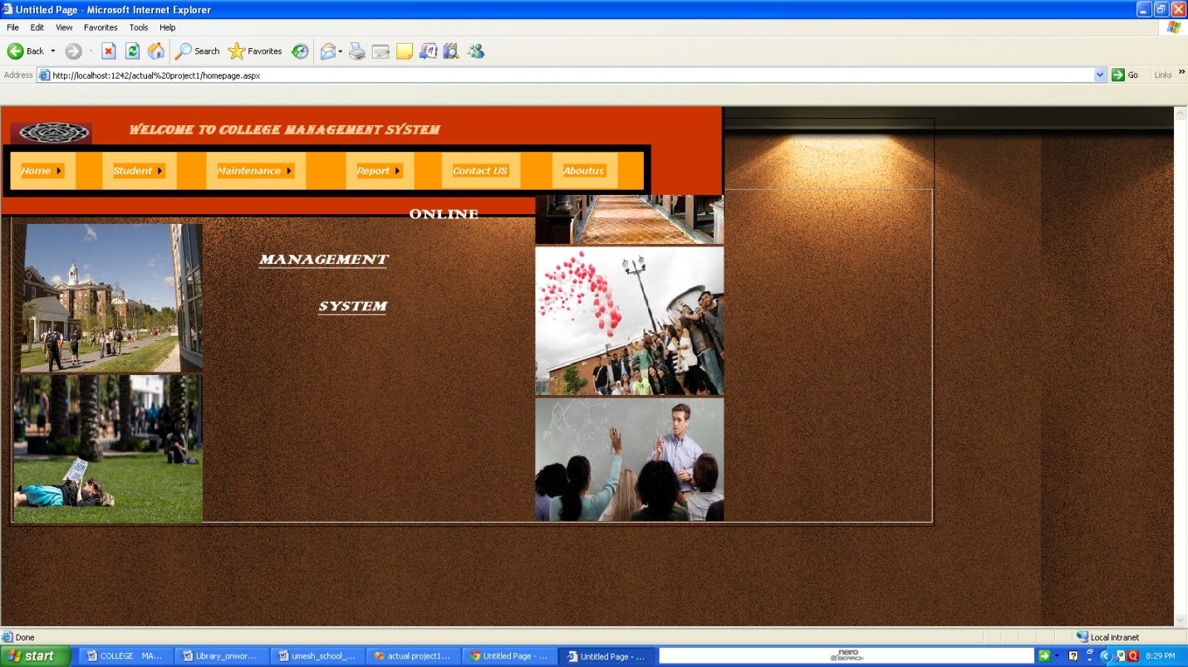

**REGISTRATION PAGE:-**

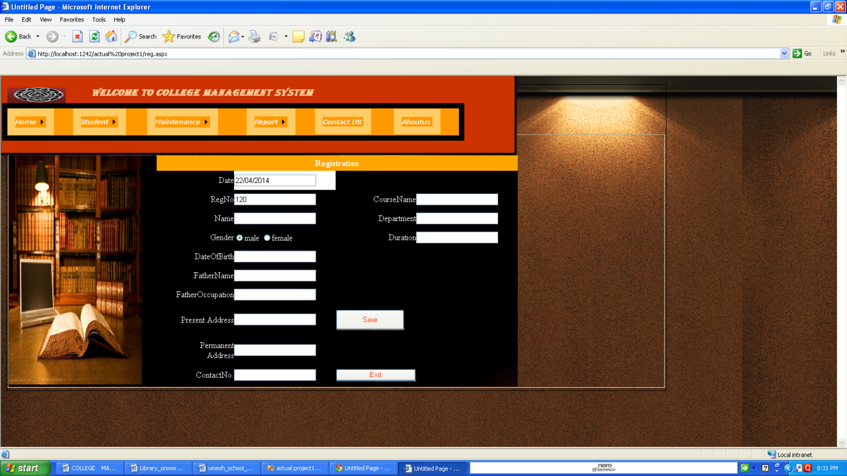

**ADMIN LOGIN PAGE:-**

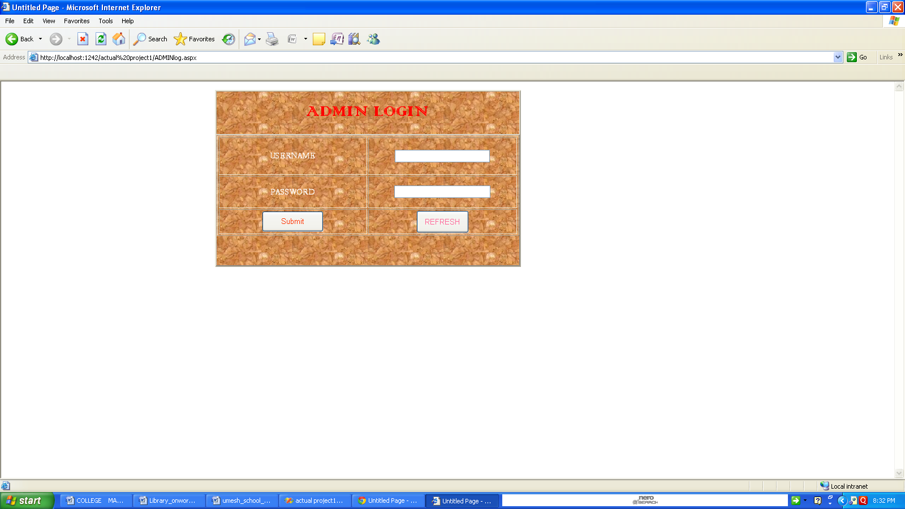

**MAINENANCE PAGE:-**

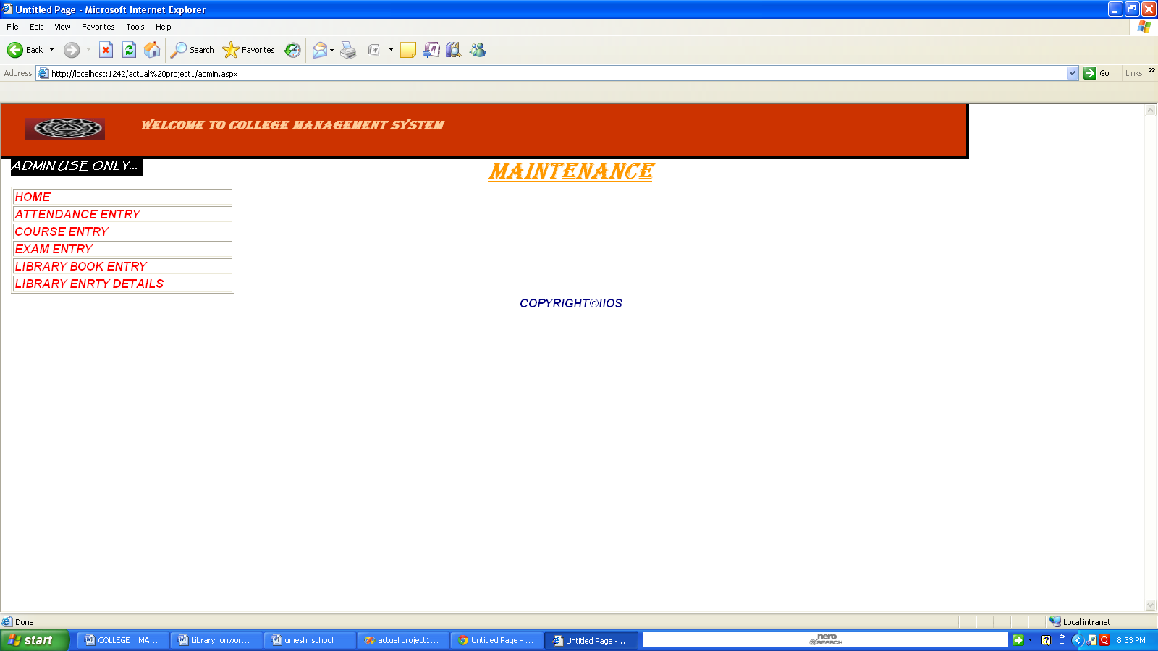

**ATTENDANCE DETAILS:-**

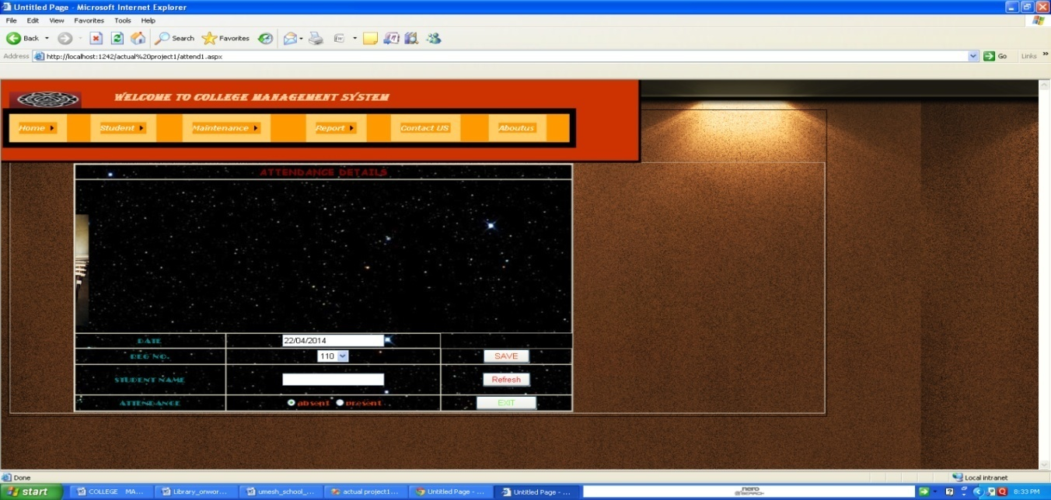

**COURSE DETAILS:-**

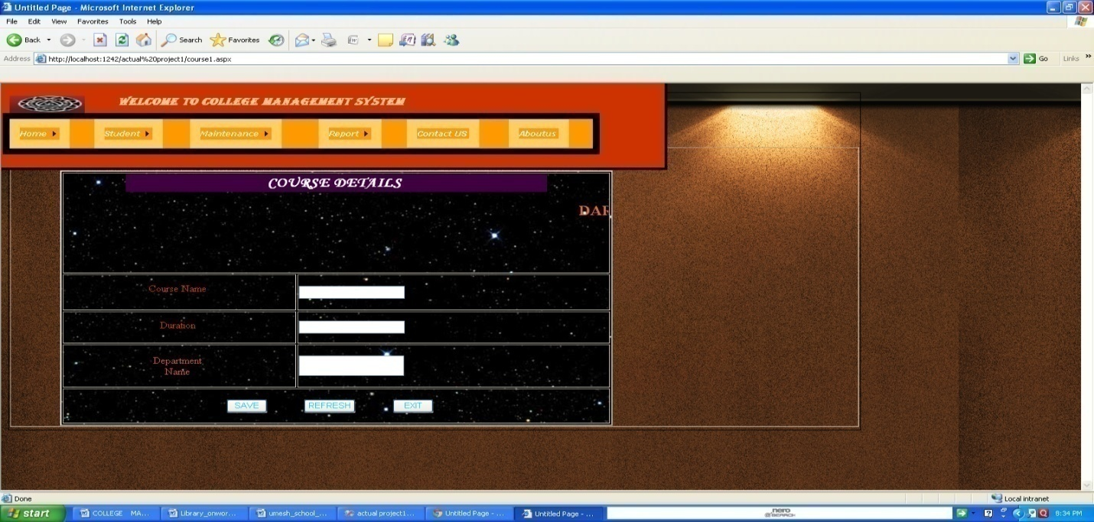

**EXAMINATION ENTRY FORM:-**

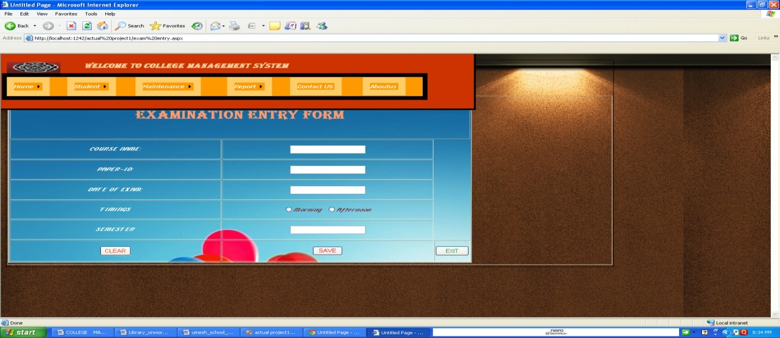

**LIBRARY ENTRY DETAILS:-**

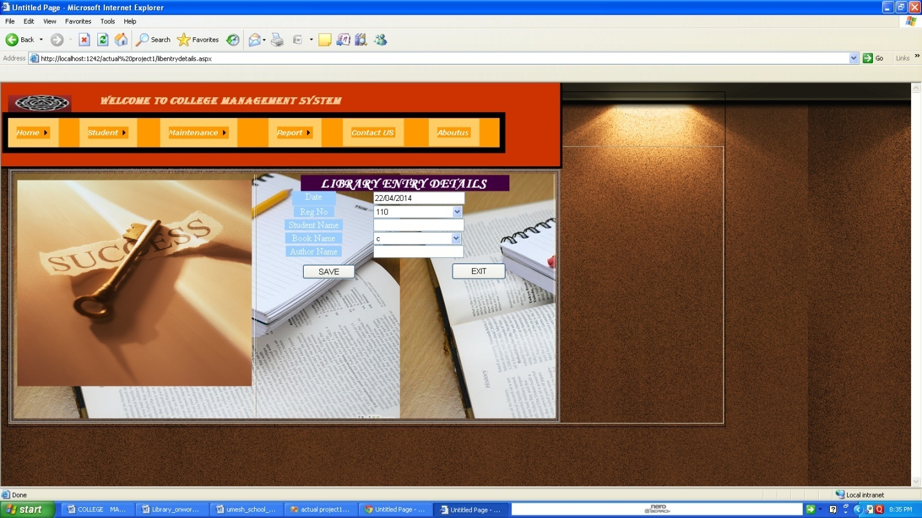

**CONTACT US PAGE:-**

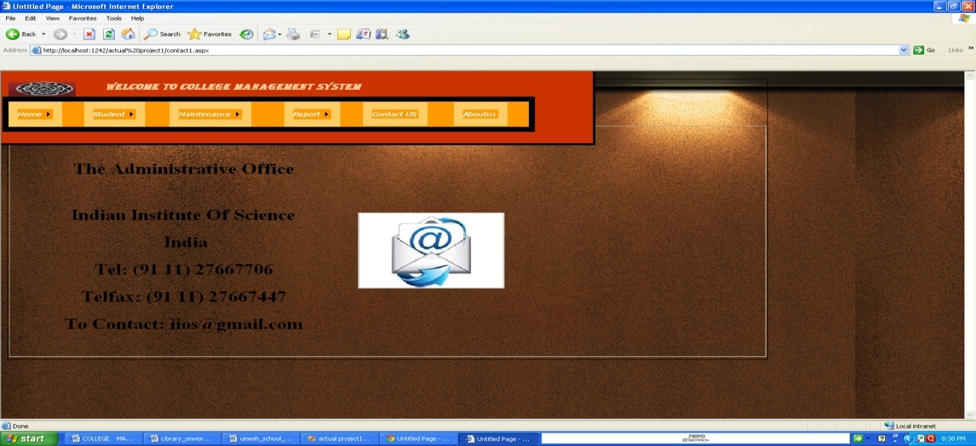

**GALLERY PAGE:-**

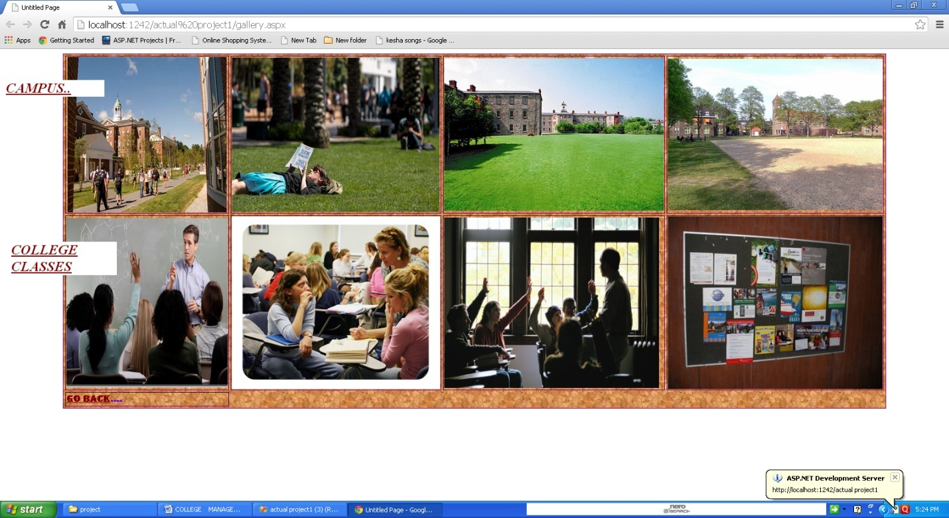

**CULTURAL AND SPORTS SOCIETY PAGE :-**

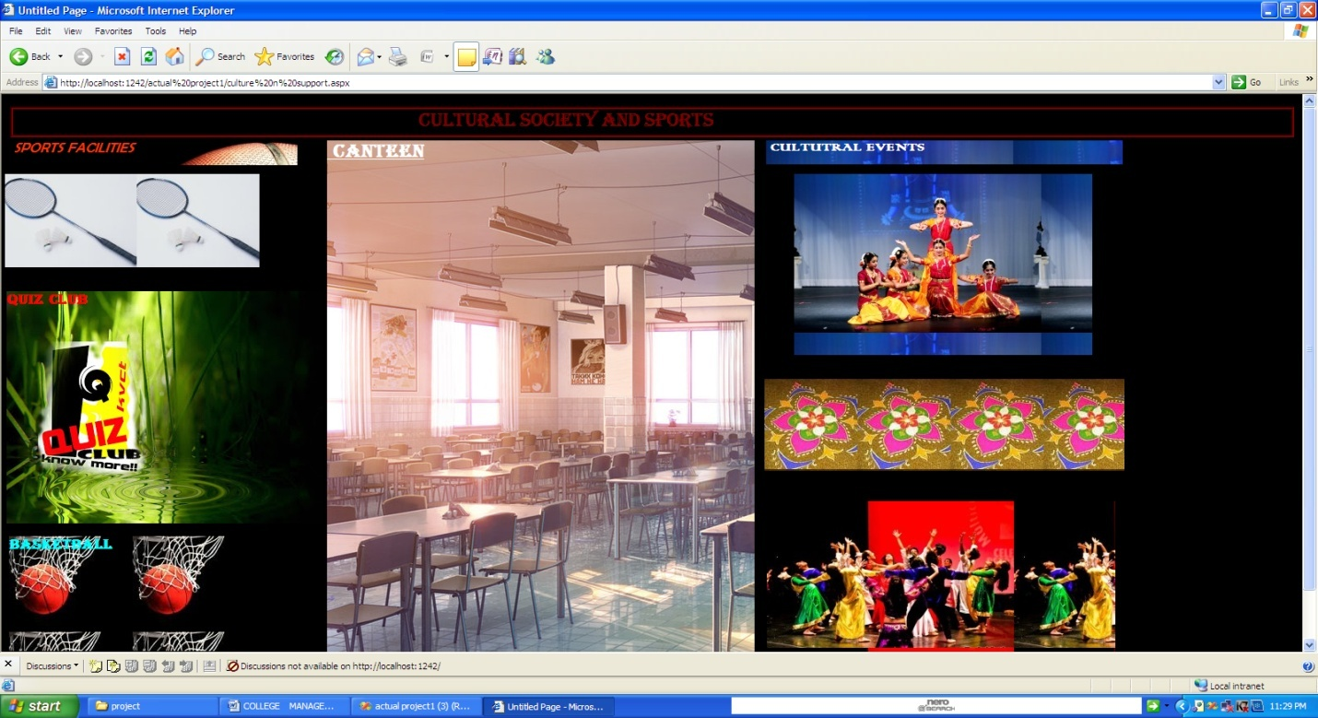**CONCLUSION**

My project is only a humble venture to satisfy the needs in a college management. Several user friendly coding have also adopted. This package shall prove to be a powerful package in satisfying all the requirements of the organization.

The objective of software planning is to provide a frame work that enables the manger to make reasonable estimates made within a limited time frame at the beginning of the software project and should be updated regularly as the project progresses.

**BIBLIOGRAPHY**

1. <http://www.vb.net.com>
2. Book prefers-

Visual basic.net

Visual basic

1. Various Educational site
2. Study of various other project